31.29: a) At resonance, the power factor is equal to one, because the impedance of the circuit is exactly equal to the resistance, so 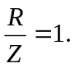
b) Average power: 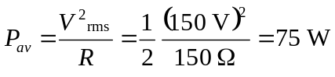.
c) If the capacitor is changed, and then resonance is again attained, the power factor again equals one. The average power still has no dependence on the capacitor, so 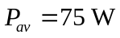 again.

